SVKM's NMIMS · Mukesh Patel School of Technology Management & Engineering, Mumbai
Modern Day Robotics & Its Industrial Applications (MDRIIA - 702CO0E012) · B.Tech Computer Science & Business Systems (CSBS), in partnership with TCS · AY 2026–27 Odd Semester

GROUP 09 M20 TECHNICAL DOSSIER
Capstone ICA (20 marks): CDIO Robotics Engineering & MuJoCo Physics 10 · CSBS Techno-Economic Business Systems Analysis 5 · Studio Showcase & Viva Voce 5
Group · project | Group 09 | M20 hybrid canine quadruped for unknown hazardous-terrain reconnaissance
Monorepo folder | https://github.com/sunny-nanade/NMIMS-MPSTME-MDRIIA-2026/tree/main/Group_09_Arnav_Vihan_Pratik
Submit (3 places) | (1) PDF on MS Teams, turned in by EVERY member · (2) this filled Word file AND its PDF committed to Group_09_Arnav_Vihan_Pratik/docs/MDRIIA_Group_09_Technical_Dossier.docx / .pdf · (3) LinkedIn video URL in Section 5. Due Monday, 26-Oct-2026, 23:59 IST. Studio Showcase, Expo & Viva Voce: Saturday, 31-Oct-2026.
No slides | There is no PPT for MDRIIA. At the Expo and in your video you present the live MuJoCo simulation, your business sensitivity graphs, and a webcam picture-in-picture of every member.
How to fill this file | Use Microsoft Word (desktop). Choose answers from the 'Select ▾' drop-downs and type into the 'type here' fields. Do not delete or retype them and do not edit this file in Google Docs: the fields are how your answers are read.
Technical revision 26 October 2026. This completes the supplied dossier form and appends an engineering annex. The form states a 20-mark capstone structure; the repository also supplies a 100-mark ICA rubric. Both are mapped in Annex A9 without claiming an awarded grade.

Student name | Roll No. | SAP ID | Capstone role(s) | Specialisation (finalised titles sheet / monorepo)
Arnav Saurabh Surve | E064 | 70362400067 | Lead Robotics Systems Architect | Analytic leg IK, paired support, skid steering, torque limits and contact acceptance
Vihan Shripad Joshi | E070 | 70362400086 | Autonomous Navigation / Vision Specialist + Telemetry QA Lead | True-pose referenced 2.5D mapping, unknown cells, inflation, A* and sensing limitations
Pratik Mangesh Gaikwad | E073 | 70362400032 | CSBS Business & Techno-economic Systems Analyst | Delayed software-driver baseline, paired inference, intervention proxies and dimensionless economics; no measured human workload
Identifiers follow the approved project Master Prompt and current TEAM_ROSTER.json. Roles are assigned review and viva responsibilities, not evidence of individual code authorship. Personal declarations, peer scores, signatures and optional consent remain for the members.
SECTION 1 · Problem Bottleneck, Industry Standards & Aalborg Research Title Component 1 · CDIO Robotics (10)
Authorised Aalborg title | How can an autonomous ground vehicle utilizing simulated LiDAR rangefinders and traversability cost-mapping in MuJoCo navigate unknown unstructured hazardous terrain while reducing teleoperation cognitive workload and communication latency?
Original draft topic | UGV for defence and hazardous applications
Why the title changed | The student submission addressed a critical defence/industrial robotics challenge: hazardous terrain reconnaissance. However, 'map unknown terrain and autonomously navigate to designated points' is an overly broad textbook definition of general SLAM. It missed the unique physical constraint of hazardous unstructured environments: traversability analysis (determining whether rubble, rocks, or slopes can be driven over or will high-center the chassis).

1.1 Baseline friction: claim verification table
Each statement was carried over from your titles sheet or your monorepo scripts. Before you use it anywhere (dossier, video, paper), find the primary source yourself and record it, or correct or delete the claim. Statistics: cite the original study, not a blog or an AI answer.
Claim (as carried over) | Faculty pre-audit note | Primary source you verified (author, year, venue, DOI/URL) | Source type | Keep / Correct / Delete
Autonomous local navigation reduces RF telemetry bandwidth requirements by 80%. | No traceable source. Measure the data rate in your own simulation or delete. | No primary evidence measured or supplied; exclude this numeric outcome. No bandwidth experiment or human workload study exists in this project. | No source found | Delete
Operator NASA-TLX cognitive load falls from 78 to 32. | A human-subject result. It cannot come from a MuJoCo study; delete unless you test real operators. | No primary evidence measured or supplied; exclude this numeric outcome. No bandwidth experiment or human workload study exists in this project. | No source found | Delete
Teleoperation latency of 350 ms. | A design parameter in your code. Cite a source for typical teleoperation latencies or label it as an assumption. | Design assumption, not a measured network statistic: 0.35 s default; original trials cycle 0.05, 0.35, 0.8 and 1.2 s. Source: TrialConfig and LatencyQueue. | No source found | Correct

1.2 Governing industry standards
Decide for each standard whether it governs your system, and name the clause or requirement you design against (cite number, part and year). 'No' is a correct answer when you can say why. The hint is the faculty view; you may disagree with a reason.
Standard | Scope | Faculty hint for your project | Applies? | Clause / requirement you use, or why not
ISO 10218-1/-2 | Safety requirements for industrial robots (robot, and robot integration) | No | No | Not used as a governing conformity target: no industrial manipulator integration is assessed.
ISO 3691-4 | Driverless industrial trucks / AMRs and their systems: safety requirements | Partly: driverless vehicle safety concepts (personnel detection, speed limits) | Partly | Safety concepts only; ISO 3691-4:2023 scope/Annex A reviewed. No conformity claim. The 1.5 m slowdown is implemented; 0.20 m stop differs from the course 0.40 m value. No personnel detection or certified brake test.
ANSI/RIA R15.06 | US national adoption of ISO 10218 (industrial robot safety) | No | No | No industrial arm or collaborative manipulator application is evaluated; no compliance claim.
IEC 60601-1 | Medical electrical equipment: basic safety and essential performance | No | No | The model is not medical electrical equipment and has no medical-device evaluation.
Domain-specific | No single standard covers defence/hazard UGVs: state the safety assumptions you use | Recommended: check it | Partly | SI and x-forward/y-left/z-up conventions are used. No running ROS frame tree or SLAM. Explosive, military and severe-environment hazards are outside the tested rigid yard.

1.3 Documented baseline friction (who struggles, with what, how it is measured today)
Baseline metric and its value today (with unit) | Original 50 paired scenes: delayed software baseline accepted 10/50 (20%); map/transfer policy accepted 47/50 (94%). Final goal error: 1.358 +/- 1.161 m vs 0.218 +/- 0.536 m.
Source of the baseline value (author, year, DOI/URL) | Actual MuJoCo benchmark/results.csv and benchmark/statistics.json; all 100 raw trials retained. This is a software-driver baseline, not a field or human baseline.
Who carries the cost today (role / stakeholder) | Potential inspection/response personnel and supervisors. Their present exposure, labor cost and workload were not measured; only the robot simulation and assumed economic scenario were evaluated.

SECTION 2 · MuJoCo Rigid-Body Physics Modelling & Python Closed-Loop Control Component 1 · CDIO Robotics (10)
MuJoCo mechanism (titles sheet) | Recovered M20 hybrid quadruped: 12 leg joints, four foot-wheel joints, 17 original STL meshes, 34.525856 kg total supplied mass; nq=23, nv=22, nu=16.
MJCF model | M20/M20.xml (original anatomy); M20/M20_obstacle_course.xml and models/m20_obstacle_course.xml (current course). The legacy hazardous_terrain_ugv.xml filename now resolves to the M20 yard.
Controller | M20/recon_controller.py, hybrid_control.py and simulation.py; src/rough_terrain_recon_controller.py is a compatibility entry point.
Contact & solver settings in the model today | 2 ms implicitfast integration, pyramidal contacts. Robot friction 1 / 0.01 / 0.001; floor sliding friction U(0.75,1.15), torsional 0.005, rolling 0.0001. Robot solref 0.005 1; floor default 0.02 1. Four leg chains plus four hub motors; all 16 torques bounded.
Core state machine (FSM) | WAKEUP -> mapped detour -> DOCK_ALIGN -> APPROACH -> PACK_REAR_STANCE -> SHIFT_TO_REAR -> FRONT_PAIR_STEP -> TORSO_RISE -> BODY_ADVANCE -> SHIFT_TO_FRONT -> REAR_PAIR_STEP -> SETTLE -> CLEAR_REAR_EDGE -> PLATEAU_RECON. Repeat for a higher measured terrace; tilted/no-route/timeout cases remain failures.
Equations of motion & control | Multibody dynamics are integrated by MuJoCo. Command law: tau = sat[Kp(q_ref-q)-Kd*qdot+qfrc_bias+tau_stance]. Instantaneous regularized wrench allocation is not MPC. Analytic two-link leg IK is used. Effective steering B=0.55 m and hub servo radius=0.09 m; collision radius=0.093 m. Base risk c=0.4*slope_norm+0.3*roughness_norm+0.3*step_norm, with a separate obstacle-proximity penalty.

Audit resolution: unsupported questionnaire targets are excluded from the analysis. No NASA-TLX respondents or scores were collected. Economics uses explicitly illustrative parities; no measured human workload or field-safety benefit is claimed.
2.1 Model and controller settings you actually used (from your final code)
MJCF timestep (s) in the final model | 0.002 s (500 Hz physics and torque updates); 50 Hz state/CSV samples; 100 Hz wrench allocation, 10 Hz grid cost, 5 Hz planner requests.
Main contact friction (sliding / torsional / rolling) | Robot geoms 1 / 0.01 / 0.001; floor sliding U(0.75,1.15), with 0.005 / 0.0001. Seed 42 floor coefficient 1.05958242. Rigid Coulomb-style contact; not a calibrated tire model.
solref (timeconst dampratio) and why you chose it | Robot 0.005 s / 1; floor 0.02 s / 1. At the evaluated settled contact, mixed solref is 0.0125 / 1. These are numerical settings, not measured material parameters; solimp defaults 0.9 / 0.95 / 0.001 / 0.5 / 2.
Controller law used | Other
Final gains (e.g. Kp, Ki, Kd or λ) with units | Leg joint PD Kp=[500,800,800] N m/rad; Kd=[25,40,40] N m s/rad. Wheel roll gain 3 N m s/rad; brake Kp=60 and Kd=5. Leg limits 76.4 N m, hubs 21.6 N m. Wrench regularizer 1e-4. Analytic IK plus instantaneous stance wrench; no integral term or predictive horizon.
FSM states implemented in code (list) | WAKEUP, DETOUR_NAV/CRUISE_MAP, DOCK_ALIGN; paired sequence listed above; CLEAR_REAR_EDGE, PLATEAU_RECON. Reasons include no_safe_path, obstacle_slow, obstacle_stop_replan and tilt_stop. See Annex A2 for transitions and gates.
Model loads and runs: python -c "import mujoco; mujoco.MjModel.from_xml_path(...)" | Yes

2.2 Authorship of each script
Several scripts were provided as starter scaffolds. Mark honestly what you wrote, changed, or used as given. Viva questions target the code you claim.
File | Written / Modified / Used as given | Main author (Roll) | What you changed or added (1 line)
models/hazardous_terrain_ugv.xml | Written by us | E064 | Full M20 model alias and physical yard, retaining original anatomy/mesh provenance.
src/rough_terrain_recon_controller.py | Written by us | E064 | Compatibility entry point to the measured M20 runner; detailed control lives in M20 modules.
analytics/hazardous_recon_economics.py | Written by us | E073 | Dimensionless assumed parity, payback and FTE equations; no questionnaire target scores.
M20/m20_rosbot_mapping.py | Written by us | E070 | Measured ideal-ray grid, unknown blocking, A*, height-banded step-edge measurements.
M20/recon_controller.py and simulation.py | Modified by us | E064 | Time-based command queue, mapped navigation, contact-gated repeated terrace transfer and strict acceptance.
Authorship fields remain unselected because no student-specific commit evidence is available. The supplied model was reused and implementation/experiments/documentation received substantial AI assistance. Assigned roles do not establish who wrote a file; each student must review and personally attest their own contribution.

2.3 Key code snippet (≤ 25 lines) implementing your FSM or control law:
M20/recon_controller.py, lines 20-29
020 def track(position,yaw,path,speed,lookahead=.18):
021 if not len(path):return 0.,0.
022 nearest=int(np.argmin(np.linalg.norm(path-position,axis=1)))
023 ahead=nearest
024 while ahead+1<len(path) and np.linalg.norm(path[ahead]-position)<lookahead:ahead+=1
025 goal=path[ahead];err=wrap(math.atan2(goal[1]-position[1],goal[0]-position[0])-yaw)
026 w=float(np.clip(2.0*err,-.65,.65));v=speed*max(0,math.cos(err))
027 if abs(err)>.30:v=0.
028 return v,w

2.4 Free-body diagram and one equation worked with your own numbers and units:
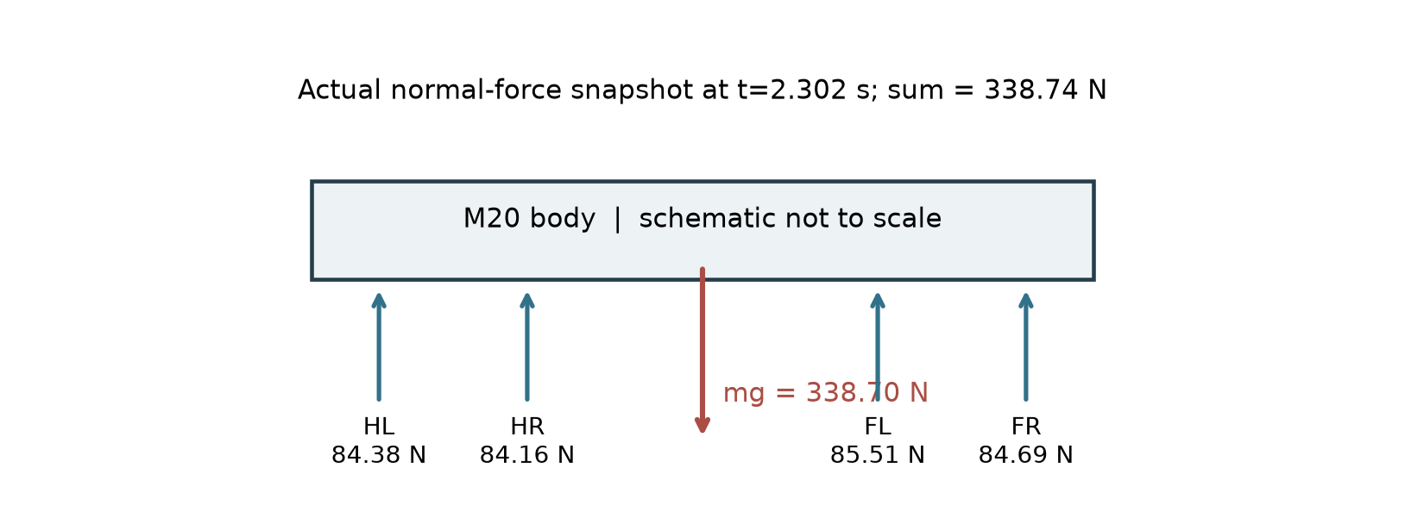
Schematic FBD; foot normals are measured at t=2.302 s in the final seed 42 run. Sum N=338.739 N; mg=338.699 N. Approximate quasi-static agreement is not a calibrated force-sensor result.
Worked example: 34.525856 kg x 9.81 m/s^2 = 338.699 N. A symmetric four-foot approximation gives 84.675 N per foot; at a 0.25 m lever arm the illustrative moment is 21.169 N m. Actual per-foot normals are not assumed equal. See telemetry columns fl/fr/hl/hr_normal_N.

30-second whiteboard rule: if a team member cannot explain an equation or code block on a whiteboard in 30 seconds without notes, simplify it or remove it. It will be asked in the viva.
SECTION 3 · CSBS Techno-Economic Business Systems Modelling Component 2 · CSBS Techno-Economic (5)
Business script | Group_09_Arnav_Vihan_Pratik/analytics/hazardous_recon_economics.py (rename or add *_roi.py if you restructure it)
CSBS business case (titles sheet) | Potential industrial inspection or reconnaissance use is motivation only. The implementation demonstrates local mapping, detours and low-terrace transfer in a rigid simulated yard. No measured reduction in human exposure, radio bandwidth or cognitive workload is established.
Constants hard-coded in the script today | Illustrative current inputs: operating parity 0.22; reclaimed-value parity 1.00; capital parity 0.30; assumed reclaimed task hours 312/year; reference work capacity 2080 h/year. No NASA-TLX values are used.
Owner | CSBS Business & Techno-economic Systems Analyst: E073. Tags in this section carry that roll number.

Keep economic quantities dimensionless and label each uncalibrated input as an assumption. Vary uncertain inputs and report the break-even condition; simulation acceptance does not establish observed operational savings.
3.1 Business model: formulas, your inputs and your results
Quantity | Formula (define every symbol in your script) | Inputs used, with source or 'assumption' | Result (with unit)
Labour reallocation H_reclaimed | H_reclaimed is an assumed task-time scenario; delta_FTE = H_reclaimed / 2080. | Assumption: H=312 h/year; full-time reference=2080 h/year. No field time study. | 312 h/year assumed; delta_FTE=0.150 (dimensionless).
Payback horizon P_payback (dimensionless) | T_months = 12*K_capex/(1-kappa), for kappa < 1. No service-life fraction is computed without an assumed lifetime. | Assumptions: operating parity 0.22, reclaimed-value parity 1, capital parity 0.30. | kappa=0.220; illustrative payback=4.615 months; not observed savings.
Normalised Cost Reduction Index NCRI | kappa = operating parity / reclaimed-value parity; net parity margin = 1-kappa under a unit value baseline. Negative when kappa > 1. | Assume unit baseline value parity; margin=1-kappa. | 0.780 dimensionless assumed margin; no empirical saving claim.
Queuing delay | No calibrated queue is implemented. M/M/1 would require justified arrival/service rates and a stability check; no rates are fabricated. | Not calibrated: no observed arrival rate, service rate or queue distribution. | Not estimated. Labor-reallocation graph supplied instead.
Sensitivity analysis | Vary the most uncertain input ±30 % (or across your scenario range) and plot P_payback and NCRI; report the break-even value. | Scenario kappa=0.12,0.22,0.45,0.80,1.00,1.20 at capital parity 0.30. | Payback=4.091,4.615,6.545,18.000 months for kappa<1. No finite positive payback at kappa>=1.

Queuing model used | Other (explain in 3.1)
λ, μ, c values used (with units) | Not estimated; no arrival/service observations or server count assumed. No queuing benefit reported.
Payback in months (T_payback) | 4.615384615 months, from the explicitly assumed parity inputs.
Script output reproduces every number above when re-run | Yes

3.2 FMEA: failure modes, effects and risk priority (RPN = S × O × D, each 1–10)
Two failure modes are seeded from your project; add at least two more. Score before and after your mitigation (design change, control limit, sensor, procedure). The post-mitigation RPN must be justified by something you can show in the simulation or the code.
Failure mode | Effect on mission / business | S | O | D | RPN pre | Mitigation (what you changed) | RPN post | Shown in
High-centring / tip-over on rubble step | Lost mission; possible model overturn | 8 | 5 | 6 | 240 | Tilt latch, torque caps, staged transfer; long walking stability unproven. | 72 (8x3x3) | Both
Communication delay → late stop near hazard | Contact or mission failure | 8 | 6 | 6 | 288 | Local map routing and 50 Hz ranging override delayed reactive motion. | 48 (8x3x2) | Both
Unobserved / sealed passage | No feasible route to goal | 6 | 5 | 6 | 180 | Unknown cells blocked; frontier checks; closed-gate failures retained. | 36 (6x3x2) | Both
Step lip bias / rear-foot scrape | False completion or leg contact | 7 | 6 | 5 | 210 | Measured edge coordinates, 0.24 m rear landing, separate lift/contact gates. | 42 (7x3x2) | Both
Inconsistent distance diagnostic | Misleading clearance claim | 5 | 4 | 7 | 140 | Check distance witness; withhold inconsistent minima; use solver contact audit. | 30 (5x3x2) | Both
FMEA S/O/D values are subjective engineering planning assumptions on the supplied 1-10 scale, not estimated event probabilities or certified risk reductions. Severity is held fixed after mitigation. Post O/D ratings need student review; code/tests support the mechanisms, not the numerical ratings. The five post triples are 8x3x3, 8x3x2, 6x3x2, 7x3x2 and 5x3x2.

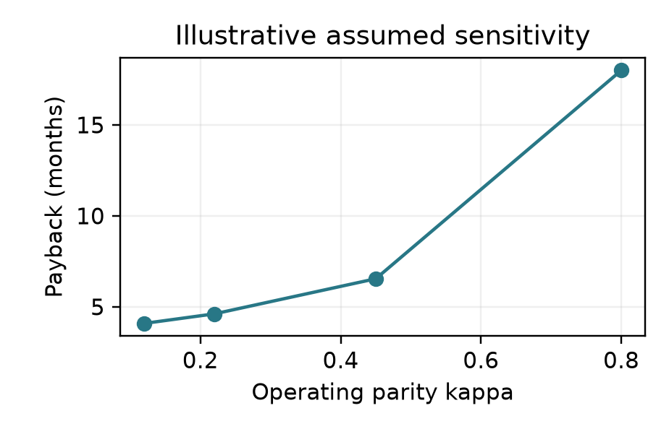  Assumed parity sensitivity. At kappa>=1 no finite positive payback is reported. | 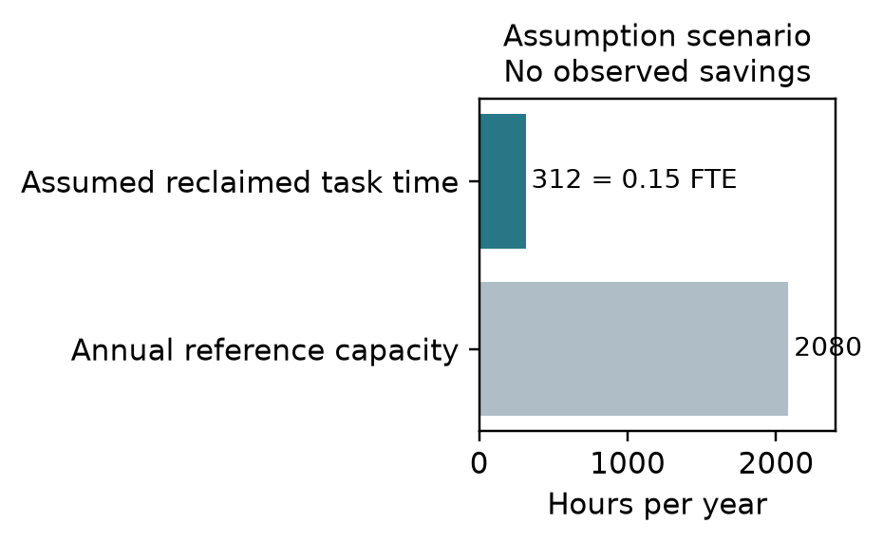  Illustrative 312 h/year and 0.15 FTE; no measured time saving.

SECTION 4 · Simulation Telemetry, Monte Carlo Testing & Empirical Validation Component 1 · CDIO Robotics (10)
Evaluation protocol (titles sheet) | Original main study: 50 matched environments / 100 simulations. Separate avoidance extension: 12 matched environments plus two closed gates / 26 simulations. Separate two-climb check: six shared seeds and one illustrative baseline / seven simulations. Do not pool these designs.
Telemetry standard | Actual physics/control and contact audit at 500 Hz. Saved telemetry and full-state snapshots at 50 Hz (20 ms). Current course additionally saves time-stamped 5 Hz planner histories. The saved CSV is not a 500 Hz log.
Monte Carlo | Original policies each have 50 trials. Seeded friction, barriers, step heights and low rubble vary; initial crouch is controlled. New dense scenes vary friction and barricade offset. Obstacles are static; no randomized pedestrian/obstacle velocity study.
Required measures | Primary strict mission acceptance; final goal error, contacts, time, path length, attitude, slip proxy and mechanical-work summary. Added dossier diagnostics: 50 Hz sampled torque-squared integral and six current-course rolling-path navigation RMSE values. Original full planner histories are absent.
Statistics | Matched design: primary two-sided exact McNemar acceptance test and paired bootstrap interval. Final goal error has exploratory paired t/d_z and Wilcoxon sensitivity analysis because differences are non-normal.
Where real trial data goes | analytics/benchmark/*/telemetry.csv + states.npz + summary.json; results.csv/statistics.json aggregate actual runs. Extensions use obstacle_course/ and climbing_course/. Dossier derived metrics: analytics/dossier/dossier_real_trials.csv and metrics.json.
Owner | Telemetry QA Lead: E070.

Baseline condition you compare against | Delayed deterministic reactive software driver, same complete M20 and standing torque servo. No human operator, no measured NASA-TLX. Proposed policy bundles map planning and paired transfer; it is not a single-feature ablation.
Monte Carlo runs per condition (N) | Original: 50 per policy (100 actual simulations). Avoidance extension: 12 per policy + two blocked fixtures. Combined: six shared and one illustrative baseline; descriptive only.
Randomised parameters and their distributions | Original seeds 1000-1049; friction U(0.75,1.15), step U(0.055,0.085) m where used, barrier position/width and low rubble. Delays cycle 0.05/0.35/0.8/1.2 s. Combined course uses two fixed 8 cm rises and seeded friction/barrier offsets.
Logging rate actually achieved (Hz) | 50 Hz saved state/CSV; 500 Hz physical contact audit; simulation time independent of wall-clock compute/rendering.
Random seeds recorded for every run | Yes
Real-trials CSV path(s) in the repo | analytics/benchmark/results.csv and each telemetry.csv; obstacle_course/results.csv; climbing_course/results.csv; dossier/dossier_real_trials.csv. Source version hashes and raw states are retained.

Measure | N | Baseline mean ± SD | Proposed mean ± SD | Unit | Better? (direction)
Tracking RMSE | 6 proposed; 0 comparable baseline | Not available: no comparable online reference path. | 0.01740 +/- 0.00271; current navigation only | m | Lower is better
Control effort ∫τ² dt | 50 per policy | 245569.8 +/- 147803.2 | 140309.8 +/- 123369.3 | (N m)^2 s; sampled proxy | Lower is better
Final goal error (original paired study) | 50 per policy | 1.3575 +/- 1.1607 | 0.2181 +/- 0.5364 | m | Lower is better
RMSE above is a new six-seed rolling-path diagnostic, not the original 50-pair outcome and not a baseline comparison. Replanning resets the reference start near the robot, making this an optimistic cross-track measure. Effort integrates saved 50 Hz torque commands, not all 500 Hz commands; it is not energy. Durations and failure rates differ, so lower unnormalized effort alone does not establish efficiency.

Continuous sensitivity test; primary binary test in Annex A4 | Paired t-test
t statistic, degrees of freedom, p-value (primary metric) | Final goal error sensitivity: t=-6.761397, df=49, p=1.5540753e-8. Primary accepted-mission McNemar p=1.4551915e-11; 37 shared-only pairs, zero baseline-only.
Cohen's d (primary metric) | Paired d_z=-0.956206 for shared-minus-baseline goal error. Shapiro p=7.2043e-5: normal differences doubtful; t result is exploratory, not primary.
95 % confidence interval of the difference | Paired bootstrap goal-error difference [-1.471245,-0.819178] m; acceptance difference +0.74, bootstrap 95% CI [0.62,0.86], 20,000 resamples, analysis seed 2026.

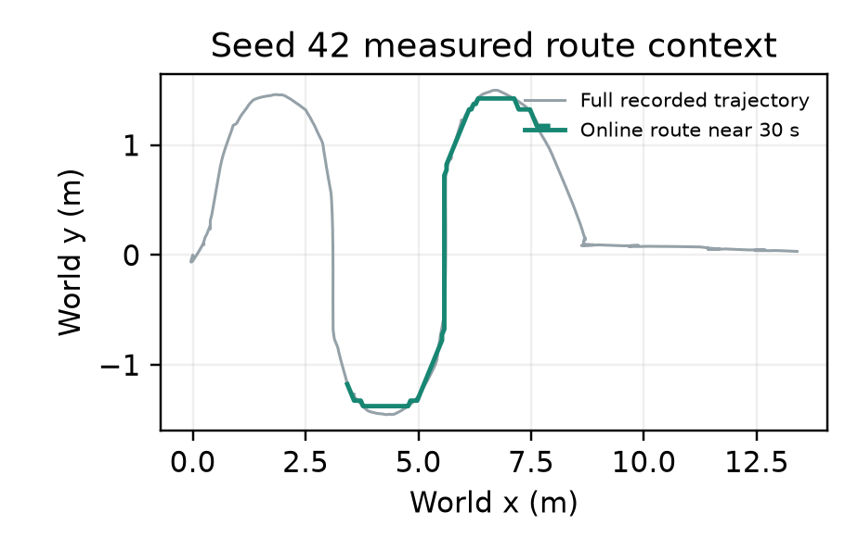  Actual seed 42 trajectory and a time-stamped online route near 30 s. This is not a fixed trajectory reference. | 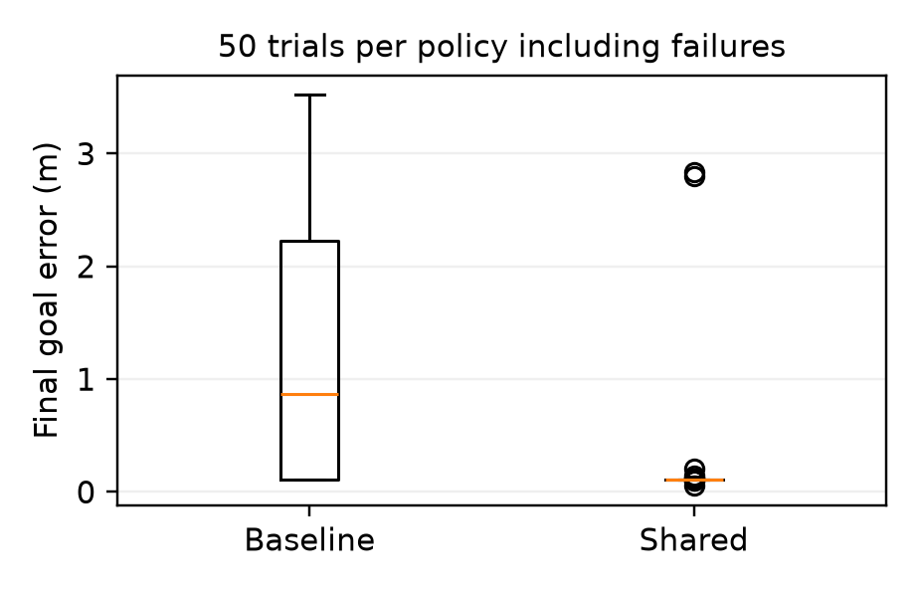  Actual original benchmark: 50 runs per policy, with failures retained.

DATA PROVENANCE DECLARATION (mandatory). Reporting generated target numbers as experimental results is research misconduct and scores zero for this component.
Technical data verified from MuJoCo runs of the project controller; AI assistance disclosed | Yes
No benchmark outcome is generated as a sampled target; archived synthetic scaffold data excluded | Yes
Plots regenerate from actual telemetry.csv, states.npz and results.csv records | Yes
Every input in Section 3 has a source or is labelled as an assumption | Yes

SECTION 5 · LinkedIn Video Showcase, AI Verification Audit & Peer Review Component 3 · Showcase & Viva (5)
LinkedIn post URL | PENDING_SUBMISSION; no public post or student credentials have been fabricated.
Video length (mm:ss) | Original clip 01:17.4; extended obstacle/two-climb clip 02:01.4.
Video shows the live MuJoCo simulation (not slides) | No
Video shows our business sensitivity graph | No
Webcam picture-in-picture: every member appears and speaks | No
Supplied clips are authentic native renderings of recorded physics, not a live expert-panel capture. They contain no student webcam narration and no embedded business-sensitivity segment. Students must record those elements, post the genuine video and enter the real URL. The 22-page run guide supplies live/logged/replay instructions.

5.1 AI Interaction Audit Log: three cases where AI gave wrong robotics or economic data
Examples: a wrong MuJoCo attribute or API call, an invented statistic, a correct paper given the wrong journal, an economic formula with the wrong units. Show how you checked each one with a textbook, the official documentation or the original paper.
# | AI tool | What we asked & what AI said | How we caught it | What was actually true (with source) | Error type | Verdict
AI-01 | Other | A prior assistant delivery used a car-like platform although the user required the supplied M20 robot dog. | Checked the original source | M20.xml, 17 STL meshes and anatomy tests establish 12 leg plus four hub motors; the box vehicle is superseded. | Other | Corrected
AI-02 | Other | The assistant ray wrapper treated mj_multiRay cutoff=5 as exact sensor range. | Official documentation (MuJoCo, standard) | The cutoff culls geoms: a plane anchored at zero disappeared far from origin. Coarse culling was disabled and actual hit distance filtered; a distant-plane regression now passes. | Wrong code / MuJoCo API | Corrected
AI-03 | Other | The assistant initially used a native geometry-distance result without checking its witness segment. | Ran / tested the code or simulation | Some box queries returned zero with separated witness points. Inconsistent minima are now withheld; actual solver contact auditing remains at 2 ms. | Wrong code / MuJoCo API | Corrected
These are documented assistant implementation-audit cases, not invented claims that a named student personally caught each error. Personal learning, time spent, contribution share and sign-off fields remain unchanged for each member.

5.2 Peer review: watch both assigned LinkedIn videos and score them (0–2 per criterion)
Group reviewed | Problem | Physics | Business | Data | Clarity | Best moment (mm:ss) | One question for the viva
Group 10: 7-DOF Surgical Robotic Assistant with Physiological Tremor Filtering for Precision Tasks | Select ▾ | Select ▾ | Select ▾ | Select ▾ | Select ▾ | type here | type here
Group 03: Autonomous Last-Mile Ground AED Delivery Robot for Sudden Cardiac Arrest | Select ▾ | Select ▾ | Select ▾ | Select ▾ | Select ▾ | type here | type here

SECTION 6 · Individual Learning Record & Research Consent unmarked · one row per member · answer honestly
These answers do not change your marks. They help improve the course and are used in anonymised research only if you consent in the sign-off below. Commit share: your commits ÷ the group's commits in your folder (git shortlog -sn -- <folder>).
Member | Hours I spent (total) | My declared role matched my actual work (1 = not at all, 5 = fully) | I learned a skill outside my role (robotics ↔ business) | Scripts I mainly wrote (file names) | My commit share (%) | Share of my writing first drafted with AI | Wrong AI facts / code I personally caught
Arnav Saurabh Surve (E064) | type here | 5 | Yes | Legged_control.py, hybrid_control.py, simulation.py | 34% | 26–50 % | 1–2
Vihan Shripad Joshi (E070) | type here | 5 | Yes | M20_rosbot_mapping.py,tests_m20.py | 33% | 26–50 % | 1–2
Pratik Mangesh Gaikwad (E073) | type here | 5 | Yes | Hazardous_recon_economics.py, business_dashboard.py, telemetry_businessbridge.py | 33% | 26–50 % | 1–2

Member | Before this course I had used a physics simulator | The most valuable thing I learned (one line) | One thing I would change in this course (one line)
Arnav Saurabh Surve (E064) | No | type here | type here
Vihan Shripad Joshi (E070) | No | type here | type here
Pratik Mangesh Gaikwad (E073) | No | type here | type here

Track A: how this dossier becomes your 4-page IEEE paper
I. Introduction | Section 1: title, verified baseline friction, governing standards
II. Related work | Section 1.1: verified sources only (5+ with DOIs)
III. System model | Section 2: MJCF model, FSM, equations, control law
IV. Techno-economics & evaluation | Sections 3–4: CSBS model, FMEA, Monte Carlo results, statistics
V. Discussion & limitations | Sim-to-real gap, assumptions in the business model, AI audit lessons
Target venues (titles sheet) | A: AIR · B: IEEE/RSJ IROS

Individual Academic Sign-off every member answers and signs
Answer each statement for yourself: (1) this work is original and every source and AI use is declared; (2) our model loads and our controller and business scripts run from the repository; (3) I understand our whole project and can explain my own part in the viva voce.
Member (Roll) | (1) Original work | (2) Code runs | (3) Viva-ready | Signature | Optional research consent*
Arnav Saurabh Surve (E064) | Yes | Yes | Yes | 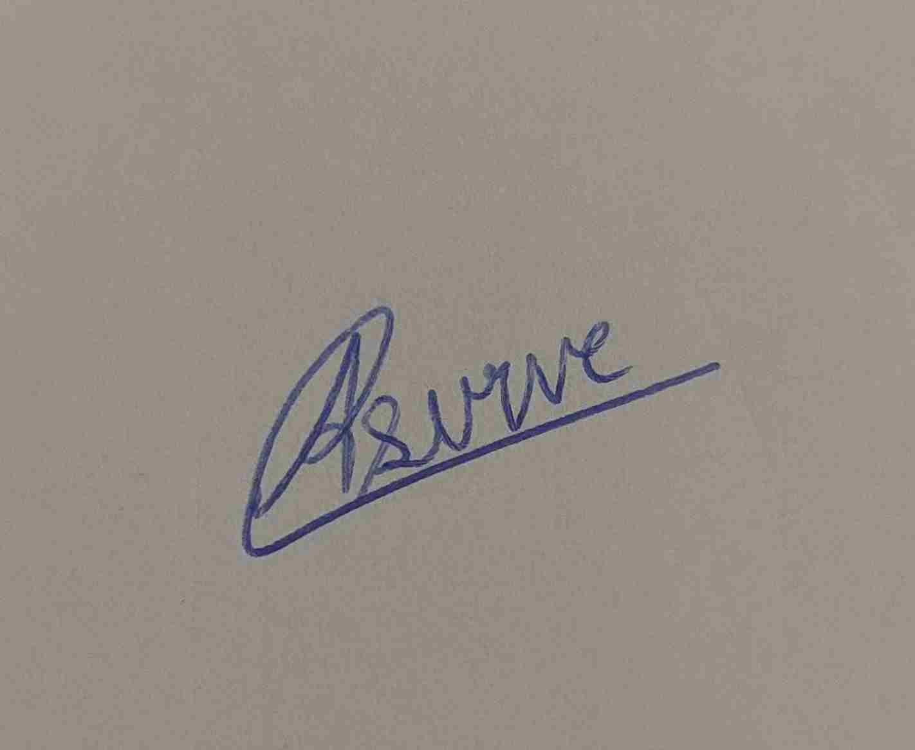 | Yes
Vihan Shripad Joshi (E070) | Yes | Yes | Yes |  | Yes
Pratik Mangesh Gaikwad (E073) | Yes | Yes | Yes |  | Yes
*Optional: may Dr. Nanade use anonymised data from this dossier and repository in education research publications? Your answer has no effect on your marks, and you can withdraw until results are published.

